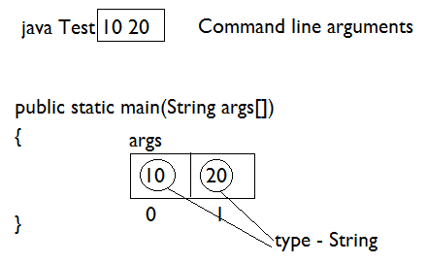

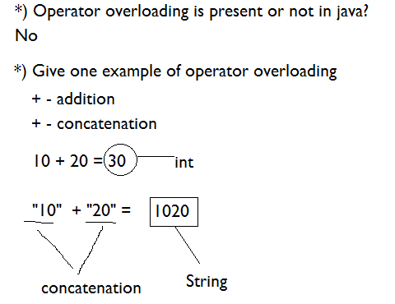

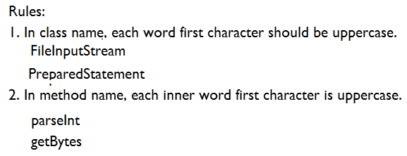

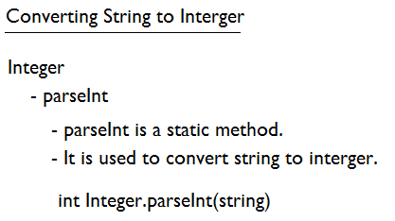

Program#1: Write a program to read 2 integer value using command line argument and find the sum.

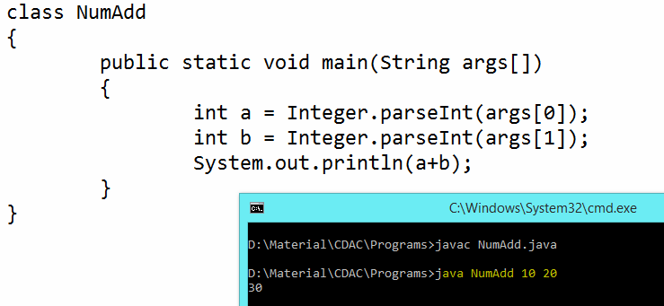

**Conditional and Looping Statements**

* If, else if, switch
* for loop
* while loop
* do while loop
* break & continue keyword
* Recursion

**If Statement**

* if statement consists of an expression followed by one or more statements.

**Syntax**

if(expression)

{

// Statements will execute if the expression is true

}

**Example#1**

public class Test

{

public static void main(String args[])

{

int x = 1;

if( x < 2)

{

System.out.print("This is if statement");

}

}

}

**Example#2  
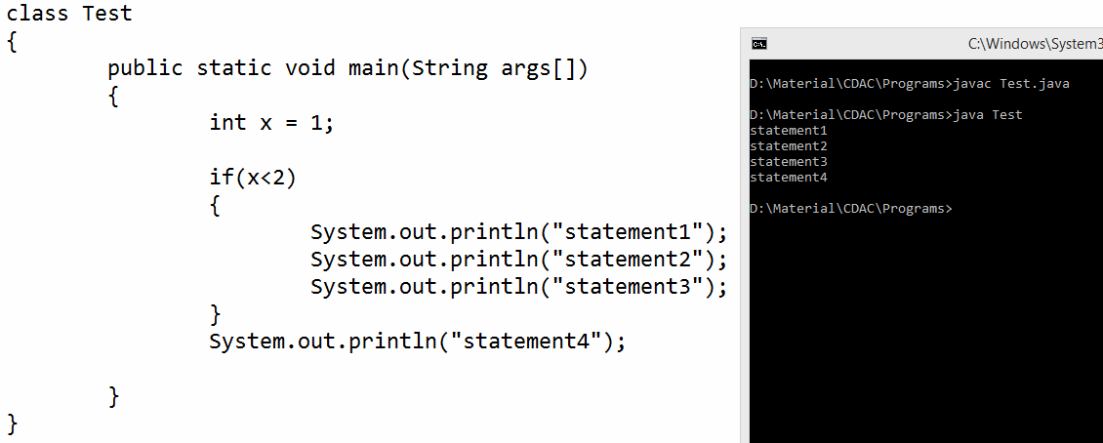**

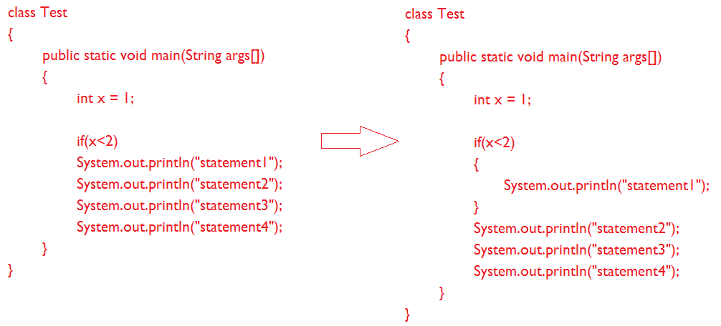

**Example#3**

class Test

{

public static void main(String args[])

{

int x = 1;

if(x>2)

System.out.println("statement1");

System.out.println("statement2");

System.out.println("statement3");

System.out.println("statement4");

}

}

**if-else statement**

**Syntax**

if(expression)

{

// Executes when the expression is true

}

else

{

// Executes when the expression is false

}

**Example**

class AgeChecker

{

public static void main(String args[])

{

int age = 20;

if(age >= 18)

{

System.out.println("You are eligible for voting");

}

else

{

System.out.println("You are not eligible for voting");

}

}

}

**If-else-if Statement**

**Syntax**

if(expression 1)

{

Statement(s) to be executed if expression 1 is true

}

else if (expression2)

{

Statement(s) to be executed if expression 2 is true

}

else if (expression3)

{

Statement(s) to be executed if expression 3 is true

}

else

{

Statement(s) to be executed if no expression is true

}

**Example**

class NumberChecker

{

public static void main(String args[])

{

int number = 0;

if (number > 0)

{

System.out.println("The number is positive.");

}

else if (number < 0)

{

System.out.println("The number is negative.");

}

else

{

System.out.println("The number is 0.");

}

}

}

**Switch**

switch(expression)

{

case x:

// code block

break;

case y:

// code block

break;

default:

// code block

}

* The value of the expression is compared with the values of each case.
* If there is a match, the associated block of code is executed otherwise default will execute.

**Example**

class NumberChecker

{

public static void main(String args[])

{

int a = 3;

switch(a)

{

case 1:

System.out.println("a is 1");

break;

case 2:

System.out.println("a is 2");

break;

case 3:

System.out.println("a is 3");

break;

default:

System.out.println("default");

}

}

}

**Fall through in switch case**

class NumberChecker

{

public static void main(String args[])

{

int a = 3;

switch(a)

{

case 1:

System.out.println("a is 1");

case 2:

System.out.println("a is 2");

case 3:

System.out.println("a is 3");

default:

System.out.println("default");

}

}

}